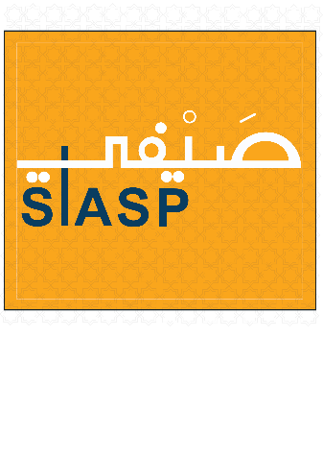

**Saifi Immersive Arabic Summer Program**  
**June 30 – August 1, 2025**  
**Application Form Deadline: Friday, June 20, 2025**  
**Levels Offerings: Urban Arabic Beginner – Elementary** [**CEFR (A1-B1) ACTFL (Novice –Intermediate- mid)]**

**Important Information**

Before completing this form, ensure you have reviewed the **Saifi Arabic Summer Program Details**. Please check the checklist at the end to include all required documents for processing.

**Applicant Information**

* **Family Name (as on passport):** [____________________]
* **First Name:** [______________________]
* **Middle Initial:** [_____]
* **Gender:** (Select one)
* **Date of Birth (DD/MM/YYYY):** [***/***/_____]
* **Nationality:** [______________________]
* **Country of Birth:** [______________________]
* **Email Address (check frequently):** [______________________]
* **Phone Number:** (+[____**]) [**____________________]
* **Mailing Address:** [____________________________________]

**Emergency Contact Information**

* **Family Name:** [______________________]
* **First Name:** [______________________]
* **Relationship to Applicant:** [______________________]
* **Email Address:** [______________________]
* **Phone Number (WhatsApp preferred):** (+[____**]) [**____________________]

**Academic Information**

List of the colleges or universities you have attended or are currently attending:

* **Institution:** [_____________________________________]
* **Degree (BA/MA/PhD):** [_____________________________]
* **Completion Date:** [_________________________________]

**Arabic Knowledge**

1. Have you studied Arabic previously?

If yes, where did you study the Levantine dialect? (Check all that apply)

1. **What level have you reached in Levantine Arabic?**  
   [***]  
   If none of the above applies, mention the topics you have covered:  
   [***]  
   [______________________________________________________________________]
2. **Which books have you primarily used to study Levantine Arabic?**  
   [____________________________________________________________________]
3. **Total number of hours studied Levantine Arabic (estimate):** [_______] hours.
4. **Have you participated in any similar language immersion programs before?**
   * If yes, please specify:  
     [***]  
     [***]

**Personal Statement**

Attach a document (100 words max) describing:

* Your motivation for attending SIASP
* Your goals for learning Arabic
* Your future career aspirations

**Reference**

Submit a reference for one of the following:

* Your most recent Arabic teacher
* A tutor or lecturer familiar with your work
* Your employer

The reference should discuss your **work ethic, focus, commitment to learning new languages, and ability to succeed in an immersive program**.  
**Provide an up-to-date email for the referee.**

**Tuition and Fees**

* **SIASP Urban Arabic:** **$1500**
* **All fees must be paid by June 20, 2025.**

**Saifi Institute Policies**

By signing this application, you confirm that you have read and agree to comply with all **Saifi Institute policies**, including:

* Class attendance requirements
* Behavior standards
* Refund policies

**Student Declaration of Commitment**

By signing below, you commit to:

* Actively participating in the SIASP
* Utilizing Arabic to the fullest
* Adhering to the program's rigorous demands

**Name:** [_______________***]  
Signature: [_______*]  
Date:[**___________________________________]

**Checklist for Application Submission**

Ensure all the following documents are submitted with your application:

**Send your completed application to:** **siasp@saifiarabic.com**